Launcher Art Requirements

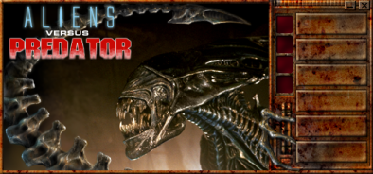

- MainBackground.bmp – The main background is a bitmap that has space for all of the buttons and animations. For NOLF, the components on the main background are:
- Close Button
- Minimize Button
- Install/Play Button
- Multiplayer Button
- Display Button
- Options Button
- Uninstall Button
- Quit Button
- As many animations (in the form of sequences of .bmp images) as desired – at least one.
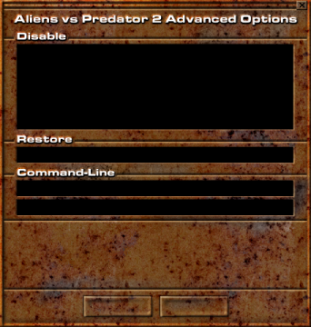

- OptionsBackground.bmp – The options background is a bitmap that has space for all of the options. For NOLF, the components on the options background are:
- Close Button
- Header text
- Disable section (consists of the following options)
- A “Disable Sound” check control
- A “Disable Music” check control
- A “Disable Movies” check control
- A “Disable Fog” check control
- A “Disable Triple Buffering” check control
- A “Disable Joysticks” check control
- A “Disable Hardware Cursor” check control
- A “Disable Animated Load Screen” check control
- Restore section (consists of the following options)
- A “Restore Default Settings” check control
- Command-Line section (consists of the following)
- An area for the user to type in the command line string
- A “Always Specify these Command-Line Parameters” check control
- Space for description
- OK Button
- Cancel Button

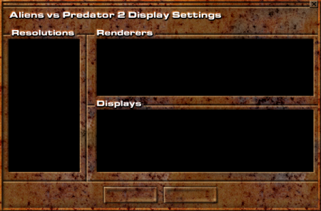

- DisplayBackground.bmp – The display background is a bitmap that has space for all of the display options. For NOLF, the components on the display background are:
- Close Button
- Header text
- Resolutions Section
- Renderers Section
- Displays Section
- OK Button
- Cancel Button
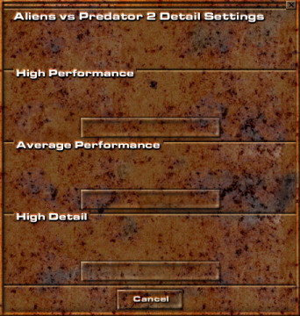

- DetailSettingsBackground.bmp – The detail settings background is a bitmap that has space for the three detail settings. For NOLF, the components on the detail settings background are:
- Close Button
- Header text
- High Performance Section
- Average Performance Section
- High Detail Section
- Cancel Button
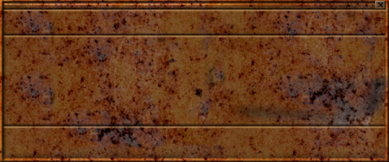

- BoxBackground.bmp – The box background is a bitmap used for generic messages and questions for the user. The components on the box background are:
- Close Button
- Header area (at the top)
- Message area (in the middle)
- Buttons area (at the bottom) – This is where the OK and Cancel buttons will be drawn, and they must be the same as the OK and Cancel buttons used in the other sections of the launcher.
- Description bitmaps (these are drawn in the upper-left corner of the message area depending on the type of message the box is being used for)
-  Error.bmp
-  Information.bmp
-  Warning.bmp
Art Format

- Backgrounds:
- All backgrounds must be non-palettized full color (16 or 24 bit) images in Windows .bmp format.
- There are no size requirements, but bear in mind that some users keep their displays at 640x480, so no image should exceed (or hopefully even come close to) that size. ☺

- Push Buttons:
  - All push buttons must be non-palettized full color (16 or 24) bit images in Windows .bmp format.
  - All push buttons need to have their images named with “U”, “D”, “F”, and “X” in their filenames like this: If the button says “Quit” on it, then you need to make the following files:
- QuitU.bmp – The close button in its up (normal) state.
- QuitD.bmp – The close button in its down (pushed) state – note that in this example, since the button lights up when the mouse rolls over it, it also remains lit up when it is pushed.
- QuitF.bmp – The close button when the mouse rolls over it (lit up or highlighted in some way).
- QuitX.bmp – The button when it is disabled (grayed out).

- Check Controls:
- All check controls must be non-palettized full color (16 or 24) bit images in Windows .bmp format, should be anti-aliased to whatever background they’re being drawn on, and should actually contain that background in the images.
- All check controls need to have their images named with “N” and “C” in their filenames like this: If the check control says “Disable Sound” on it, then you need to make the following files:
- DisableSoundN.bmp – The control in its normal (unchecked) state.
- DisableSoundC.bmp – The control in its checked state.

- Animations:
- All animations should be in the form of a sequence of non-palettized full color (16 or 24 bit) images in Windows .bmp format.
- Animations can be looping or non-looping and can play one after another, for example, the animation of the AVP2 number “2” drawing in is a non-looping animation, and then the animation of the number 2 pulsating is a separate looping animation that starts playing right after the first animation is finished.
- Let me know the framerate at which you want the images to play back and I’ll assemble the bitmaps into an animation.

